The Bunny Fence Experiment

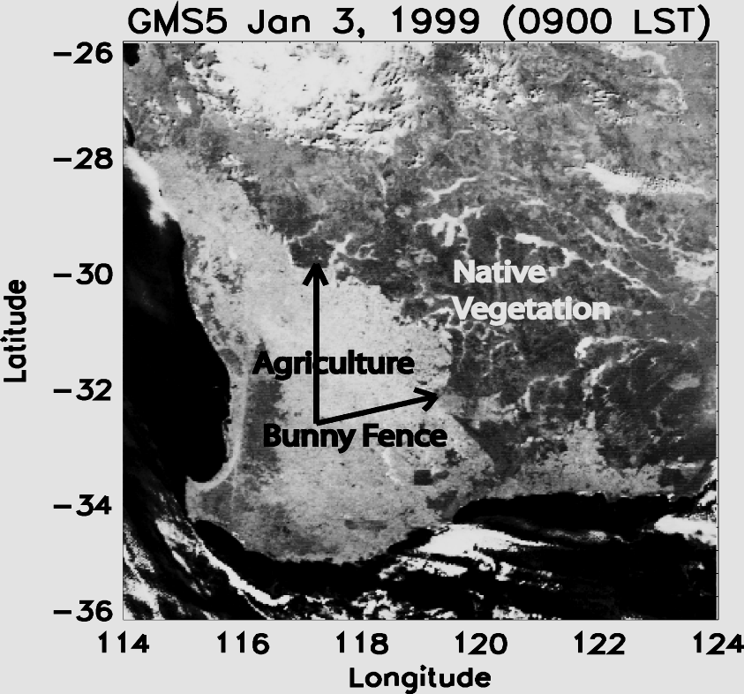
Southwest Australia is a site of drastic land use change, where an estimated 13 million hectares of native perennial vegetation have been cleared for cultivation of seasonal, winter growing agricultural species. A 750 km fence erected for protecting crops from the rabbits (bunny fence) marks the eastern boundary of the areas cleared for agricultural use. The drastic anthropogenic modification of surface vegetation in this area is a very striking feature in satellite imagery over this region. Changes in this region are representative of future changes in several other parts of the world, where native vegetation is being removed for agricultural purposes in response to demand for increased food production.
Satellite imagery over southwest Australia. Note the drastic difference in brightness between cleared and native vegetation areas

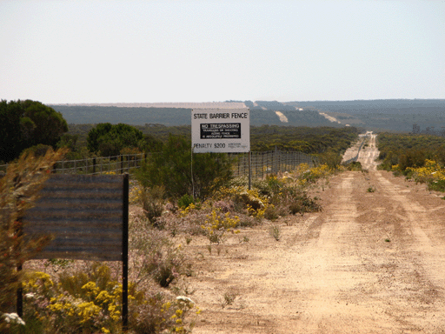
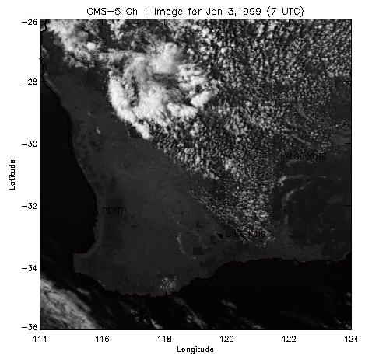
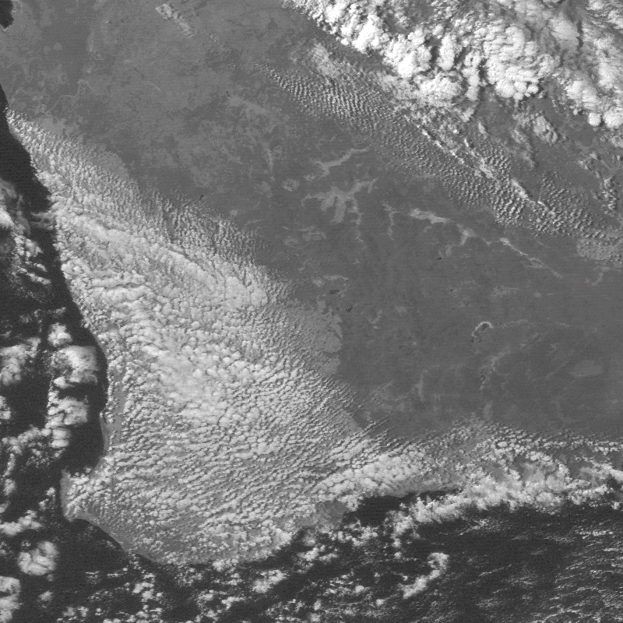
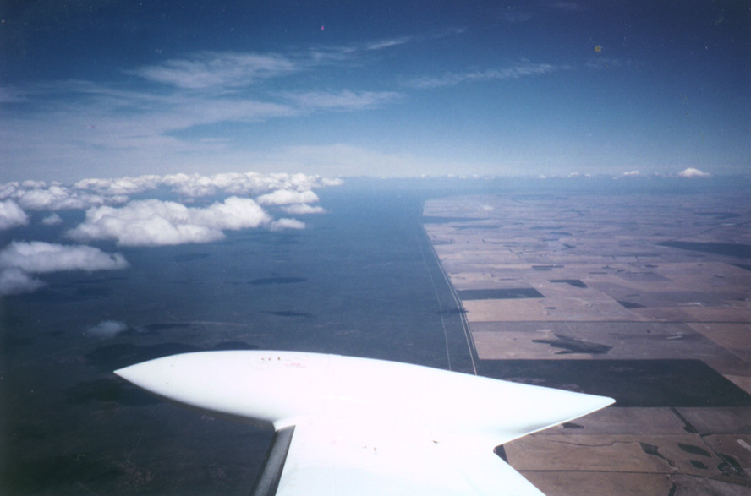
Satellite, aircraft and ground observations suggest that the anthropogenic land use change in this region may be altering the regional climate. Satellite and aircraft observations often show clouds forming preferentially over the remaining native vegetation areas, with the cloud fields abruptly terminating at the bunny fence, especially during spring and summer. Occasionally, during winter time, the opposite pattern is observed where clouds form over the western side of the bunny fence and terminate abruptly at the fence. A 20% decrease in rainfall has been reported in this area following substantial clearing of native vegetation. However, it is not clear if this is caused by the clearing of the native vegetation. One important environmental impacts of land use change in the bunny fence region, directly attributed to land use change, is the increased salinity in the agricultural areas. Extensive removal of native vegetation with deep roots has led to rising of the water table with the end result of increased salinity in the surface soil and associated decrease in agricultural productivity. Rising soil salinity poses a significant threat to agricultural productivity in the future and has serious economic consequences. Increasing salinity has lead to formation of salt lakes in the agricultural areas. Once the salt lakes form, all vegetation with the exception of particular variety of salt bushes ceases to grow in these areas. Thus the salinization process is irreversible and renders croplands into wastelands.
The Bunny Fence
Preferential cloud formation over native vegetation and croplands.
Ariel view of clouds forming preferentially over native vegetation

The Bunny Fence Experiment is a series of international, collaborative field experiments aimed at understanding the impact of land use change on cloud formation and atmospheric circulation in this region. Collaborators in this project include research teams from University of Alabama in Huntsville, USA, Murdoch University and Flinders University, Australia and FZK, IMK-IFU, Germany. The research teams are led by Dr. Udaysankar S. Nair from University of Alabama in Huntsville and Dr. Tom Lyons from Murdoch University and other team members include Dr. Ron Welch, Dr. Jorg Hacker, Dr. Wolfgang Junkermann, Dr. Roger Pielke Sr. The first two phases of the field experiments were conducted in December of 2005 and 2006. The third phase on the field experiment will be conducted in August of 2007.

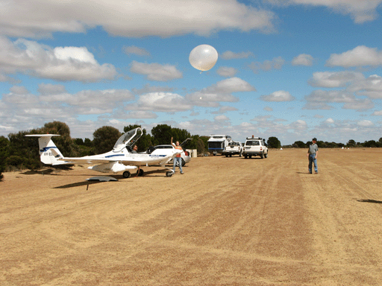
The site of the Bunny Fence Experiment is the Lake King area, located approximately 20km west of the Bunny Fence. During the field experiments, a variety of ground based, aircraft and balloon borne sensors are used to study the evolution of the atmosphere over the croplands and the native vegetation areas. The timing of the field experiments were chosen so as to sample the atmospheric conditions during the crop growing season and also after harvest. The data collected during the field experiments are directly analyzed to confirm hypotheses proposed to explain differences in cloud development between the two areas. The data collected is also used to drive and validate numerical models that allow study of pre agricultural scenarios.
Radiosonde launch during the bunny fence experiment.

This study is funded by National Science Foundation (NSF) and the Australian Research Council. The NSF funding of approximately $1 million, include use of the mobile radiosonde launch facility of the Earth Observation Laboratory of National Center of Atmospheric Research. The Australian Research Council funding support includes the use of two Small Environmental Research Aircraft (SERA) platforms of Airborne Research Australia (ARA) of Flinders University. These specialized aircrafts are designed to fly at very low altitudes (10-20m above the canopy), measuring energy fluxes in the boundary layer. One of the aircrafts also flew instruments for measuring atmospheric ultrafine and fine aerosols that serve as sites for condensation and thus are important in cloud formation processes. Other instruments used in the field experiments include surface meteorology stations, surface energy flux stations and soil sensors. High resolution NASA, ASTER satellite also acquired imagery during the field experiments.

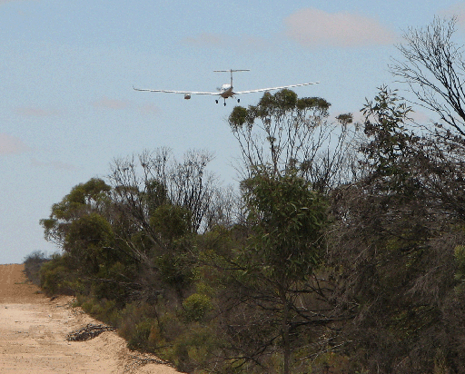
Data collected during the prior phases of the field experiment has already yielded very interesting results. Radiosonde observations show that the atmosphere is more turbulent on the native vegetation area and the heated air from near the surface mixes higher up in atmosphere more efficiently and thus more conducive to cloud formation. Radiosonde observations also show that the sea breeze arrives at the native vegetation areas earlier compared to the agricultural areas. Numerical modeling experiments show that darker vegetation in the native vegetation areas lead to enhanced absorption of sunlight at the surface causing more turbulent atmosphere. Investigations also show that agricultural areas may be more conducive to formation of dust devils. Data also show that there are more fine and ultrafine aerosols in the agricultural areas. Efficient dust devil formation over the agricultural area and transport of aerosol material into the atmosphere illustrates complex pathways through which land use impacts atmosphere.
Small Environmental Research Aircraft

For further information contact: Udaysankar S. Nair, Research Scientist III, Phone: 256-961-7841, Email: nair@nsstc.uah.edu

Mailing address: 320 Sparkman Dr, Earth System Science Center, National Space Science Technology Center, University of Alabama in Huntsville, Huntsville, AL 35805.

